**Install Move_Files_TOOL_v1.0**

Creator: Eliran Dror

**Note: all below must be installed on EDR - ACS server!**

1. After unzipping:

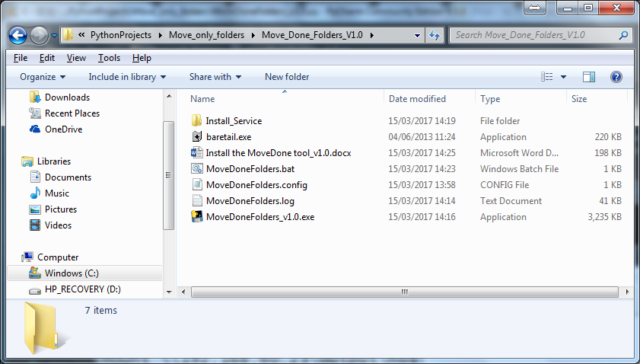

1. Edit the ‘MoveDoneFolders.config’ file according to ENV details:

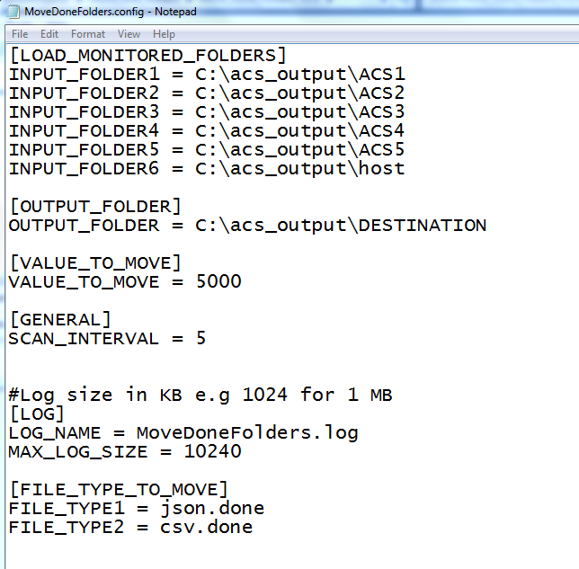

1. Create EDR_MNR service:
2. Open ‘CMD’ as administrator
3. Navigate to ’C:\<Unzipping path>\Install_Service\nssm-2.24\win64\’

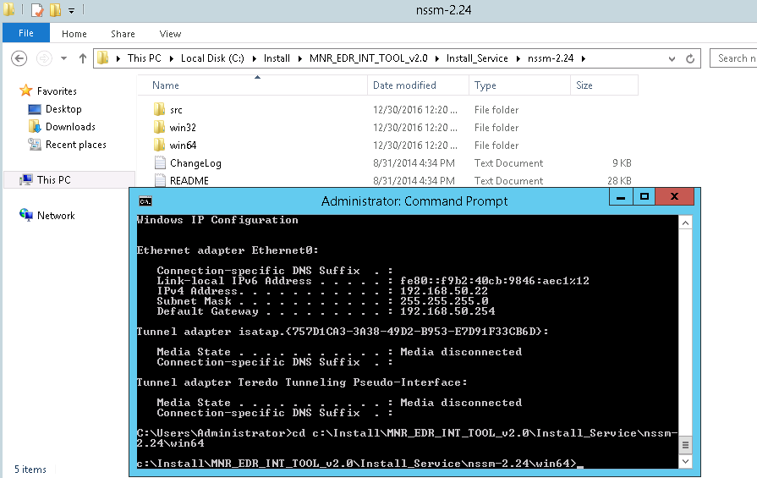

1. Run the command ‘nssm.exe install MoveDone’

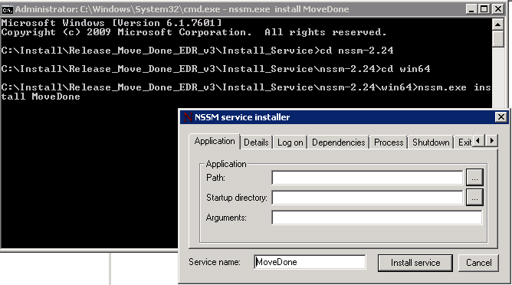

1. In the MSSM GUI, select the ‘MoveDoneFolders.bat’ file

Note!! The batch must be configured according to exe path and mapped network drive.

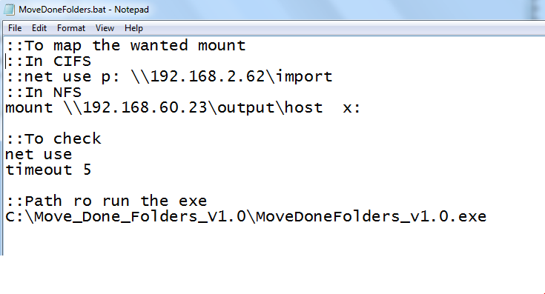

1. Press ‘Install service’ button and press OK.

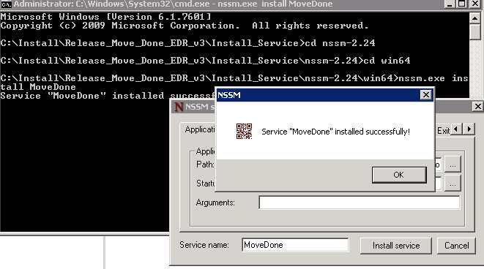

1. Go to ‘services.msc’
2. Start ‘MoveDone’ service.

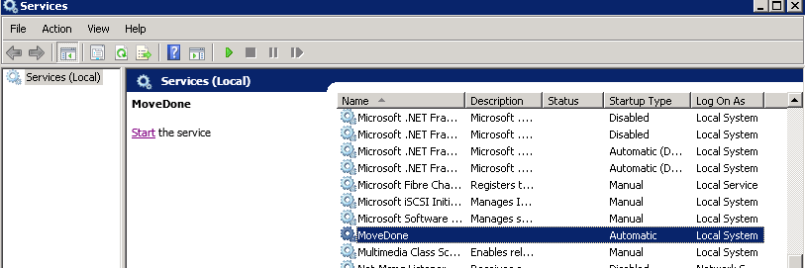

1. Check ‘MoveDone.log’ file for results (located under installation path).

